Worksheet: Introduction to Circles

Part I – Circumference and Radius

$$C=2πr$$

1. If the radius of a circle is 4 cm, what is the circumference?

2. If the radius of a circle is 8 cm, what is the circumference?

3. If the radius of a circle is 0.5 inches, what is the circumference?

$$r=\frac{C}{2π}$$

4. If the circumference of a circle is 40 mm, what is the radius?

5. If the circumference of a circle is 80 mm, what is the radius?

6. If the circumference of a circle is 94.25 inches, what is the radius?

Part II – Circumference and Diameter

$C=2πr$ and $C=πd$

1. If the diameter of a circle is 9 cm, what is the circumference?

2. If the diameter of a circle is 18 cm, what is the circumference?

3. If the diameter of a circle is 27 cm, what is the circumference?

$r=\frac{C}{2π}$ and $d=\frac{C}{π}$

3. If the circumference of a circle is 44 inches, what is the diameter?

4. If the circumference of a circle is 70 cm, what is the diameter?

5. If the circumference of a circle is 200 mm, what is the diameter?

Part III – Area and Radius

$$A=πr^{2}$$

$$d=2r$$

1. If the radius of a circle is 4 inches, what is the area?

2. If the radius of a circle is 8 inches, what is the area?

3. If the radius of a circle is 16 inches, what is the area?

4. If the area of a circle is 100 in², what is the radius? What is the diameter?

5. If the area of a circle is 200 in², what is the radius? What is the diameter?

6. If the area of a circle is 400 in², what is the radius? What is the diameter?

Part IV – Area and Diameter

1. If the diameter of a circle is 5 cm, what is the area?

2. If the diameter of a circle is 10 cm, what is the area?

3. If the diameter of a circle is 20 cm, what is the area?

4. If the area of a circle is 100 mm², what is the diameter? What is the radius?

5. If the area of a circle is 400 mm², what is the diameter? What is the radius?

6. If the area of a circle is 900 mm², what is the diameter? What is the radius?

Part V – Degree Measure of an Arc

1. If m∠APB = 80°, what is m$\hat{AB}$?  2. If m∠APB = 80°, what is m$\hat{ACB}$? | 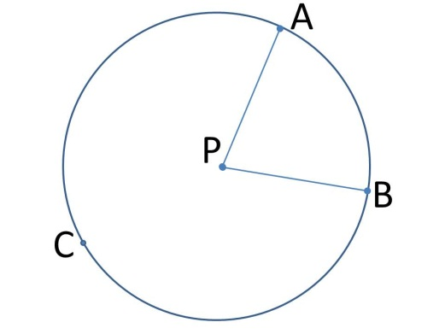
3. If m∠APB = 120°, what is m$\hat{AB}$?  4. If m∠APB = 120°, what is m$\hat{ACB}$? | 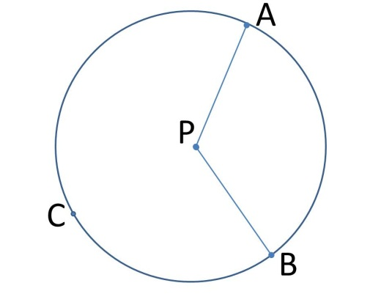
5. If m∠APB = 90° and m∠CPB = 100°, what is m$\hat{AB}$?  6. And, what is m$\hat{BC}$ ?  7. And, what is m$\hat{BCA}$ ?  8. And, what is m$\hat{BAC}$ ?  9. What is the m$\hat{AB}$ + m$\hat{BCA}$ ? | 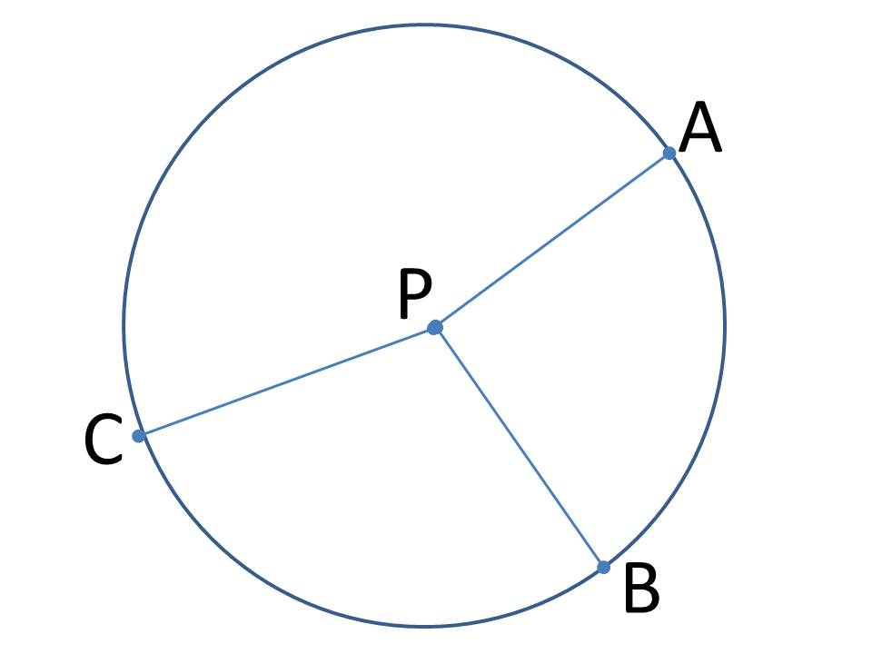

Part VI – Arc Length

1. If m∠APB = 45°, and PA = 10 cm, what is the length of $\hat{AB}$? | 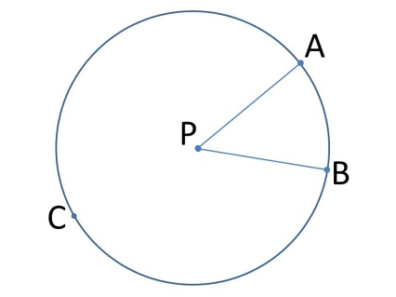
2. If m∠APB = 70°, and m∠BPC = 120°,PA = 3 cm, what is the length of $\hat{AB}$?  3. What is the length of $\hat{BC}$?  4. What is the length of $\hat{AC}$?  5. What is the circumference of circle P? | 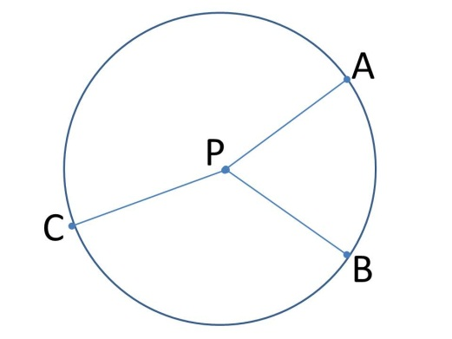
6. If AC is the diameter, m∠APB = 72°PB = 40 mm, what is m$\hat{AB}$?  7. What is m∠CPB?  8. What is m$\hat{BC}$?  9. What is the length of $\hat{AB}$?  10. What is the length of $\hat{BC}$?  11. What is the area of circle P? | 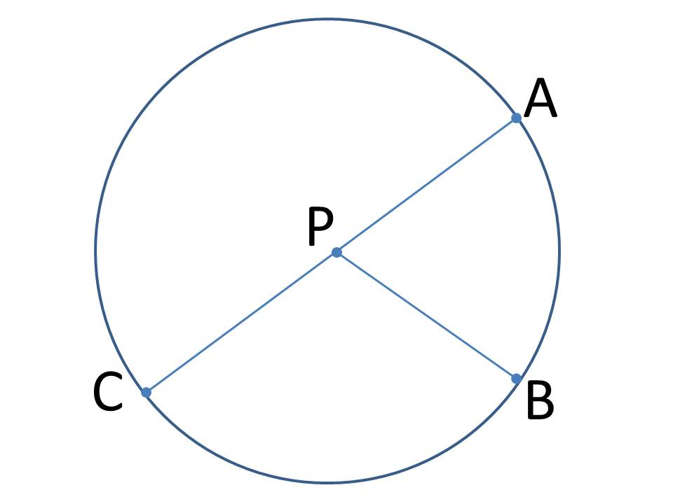

Worksheet: Introduction to Circles – ANSWER KEY

Part I – Circumference and Radius

$$C=2πr$$

1. If the radius of a circle is 4 cm, what is the circumference?

C = 2πr = 2π(4) = 8 π = 25.13 cm

2. If the radius of a circle is 8 cm, what is the circumference?

C = 2πr = 2π(8) = 16 π = 50.27 cm

3. If the radius of a circle is 0.5 inches, what is the circumference?

C = 2πr = 2π(1/2) = π = 3.14 in

$$r=\frac{C}{2π}$$

4. If the circumference of a circle is 40 mm, what is the radius?

r = C/2π = 40/2π = 20/π = 6.37 mm

5. If the circumference of a circle is 80 mm, what is the radius?

r = C/2π = 80/2π = 40/π = 12.73 mm

6. If the circumference of a circle is 94.25 inches, what is the radius?

r = C/2π = 94.25/2π = 15 in

Part II – Circumference and Diameter

$C=2πr$ and $C=πd$

1. If the diameter of a circle is 9 cm, what is the circumference?

C = πd = π(9) = 9 π = 28.26 cm

2. If the diameter of a circle is 18 cm, what is the circumference?

C = πd = π(18) = 18 π = 56.55 cm

3. If the diameter of a circle is 27 cm, what is the circumference?

C = πd = π(27) = 27 π = 84.82 cm

$r=\frac{C}{2π}$ and $d=\frac{C}{π}$

3. If the circumference of a circle is 44 inches, what is the diameter?

d = C/π = 44/π = 14 in

4. If the circumference of a circle is 70 cm, what is the diameter?

d = C/π = 70/π = 22.28 cm

5. If the circumference of a circle is 200 mm, what is the diameter?

d = C/π = 200/π = 63.66 mm

Part III – Area and Radius

$$A=πr^{2}$$

$$d=2r$$

1. If the radius of a circle is 4 inches, what is the area?

A = πr² = π(4)² = 16 π = 50.27 in²

2. If the radius of a circle is 8 inches, what is the area?

A = πr² = π(8)² = 64 π = 201.06 in²

3. If the radius of a circle is 16 inches, what is the area?

A = πr² = π(16)² = 256 π = 804.25 in²

4. If the area of a circle is 100 in², what is the radius? What is the diameter?

A = πr²
100 = πr²
r = 5.64 in and d = 11.28 in

5. If the area of a circle is 200 in², what is the radius? What is the diameter?

A = πr²
200 = πr²
r = 7.98 in and d = 15.96 in

6. If the area of a circle is 400 in², what is the radius? What is the diameter?

A = πr²
400 = πr²
r = 11.28 in and d = 22.56 in

Part IV – Area and Diameter

1. If the diameter of a circle is 5 cm, what is the area?

A = πr² = π(2.5)² = 19.63 cm²

2. If the diameter of a circle is 10 cm, what is the area?

A = πr² = π(5)² = 25 π = 78.54 cm²

3. If the diameter of a circle is 20 cm, what is the area?

A = πr² = π(10)² = 100 π = 314.16 cm²

4. If the area of a circle is 100 mm², what is the diameter? What is the radius?

A = πr²
100 = πr²
r = 5.64 mm and d = 11.28 mm

5. If the area of a circle is 400 mm², what is the diameter? What is the radius?

A = πr²
400 = πr²
r = 11.28 mm and d = 22.56 mm

6. If the area of a circle is 900 mm², what is the diameter? What is the radius?

A = πr²
900 = πr²
r = 16.93 mm and d = 33.86 mm

Part V – Degree Measure of an Arc

1. If m∠APB = 80°, what is m$\hat{AB}$?

80°

2. If m∠APB = 80°, what is m$\hat{ACB}$?

360 – 80 = 280°

3. If m∠APB = 120°, what is m$\hat{AB}$?

120°

4. If m∠APB = 120°, what is m$\hat{ACB}$?

360 – 120 = 240°

5. If m∠APB = 90° and m∠CPB = 100°, what is m$\hat{AB}$?

90°

6. And, what is m$\hat{BC}$ ?

100°

7. And, what is m$\hat{BCA}$ ?

mCA = 360 – mAB – mBC = 360 – 90 – 100 = 170
therefore,
mBCA = mBC + mCA = 100 + 170 = 270

8. And, what is m$\hat{BAC}$ ?

mBAC = mBA = mAC = 90 + 170 = 260°

9. What is the m$\hat{AB}$ + m$\hat{BCA}$ ?

360°

Part VI – Arc Length

1. If m∠APB = 45°, and PA = 10 cm, what is the length of $\hat{AB}$?  L = (M/360)(2πr) = (45/360)(2π10) = 2.5π = 7.85 cm | 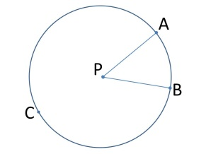
2. If m∠APB = 70°, and m∠BPC = 120°,PA = 3 cm, what is the length of $\hat{AB}$?

L = (M/360)(2πr) = (70/360)(2π3) = 3.67 cm

3. What is the length of $\hat{BC}$?

L = (120/360)(2π3) = 2π = 6.28 cm

4. What is the length of $\hat{AC}$?

L = (M/360)(2πr) = (170/360)(2π3) = 8.90 cm

5. What is the circumference of circle P?

C = 2πr = 2π3 = 6π = 18.85cm

6. If AC is the diameter, m∠APB = 72°PB = 40 mm, what is m$\hat{AB}$?
72°

7. What is m∠CPB?
180 – 72 = 108°

8. What is m$\hat{BC}$?
108°

9. What is the length of $\hat{AB}$?

L = (72/360)(2π40) = 16 π = 50.27 mm

10. What is the length of $\hat{BC}$?

L = (108/360)(2π40) = 24 π = 75.4 mm

11. What is the area of circle P?
A = 5026.55 mm²

